**Exercise 5: Cursors**

Scenario 1: Generate monthly statements for all customers.

**PL/SQL Code:**

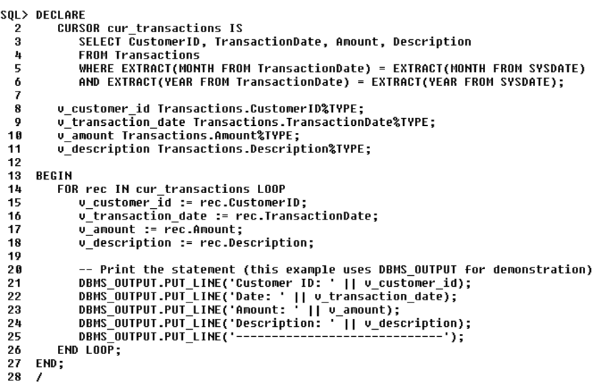

**Output:**

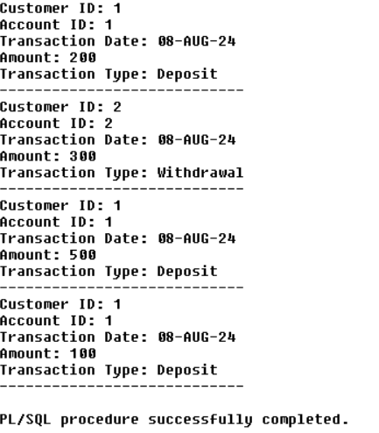

Scenario 2: Apply annual fee to all accounts.

**PL/SQL Code:**

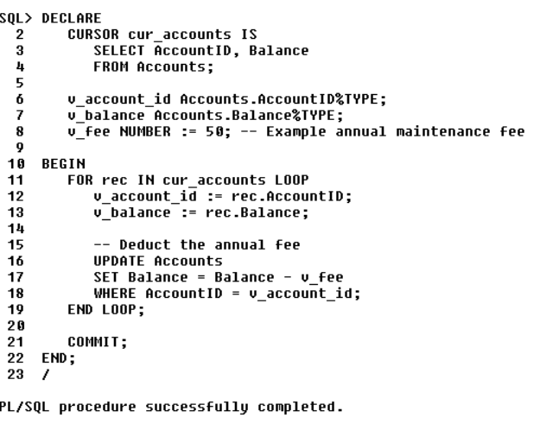

**Output:**

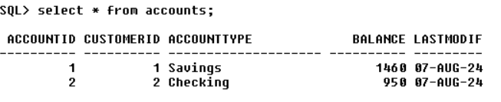

Scenario 3: Update the interest rate for all loans based on a new policy.

**PL/SQL Code:**

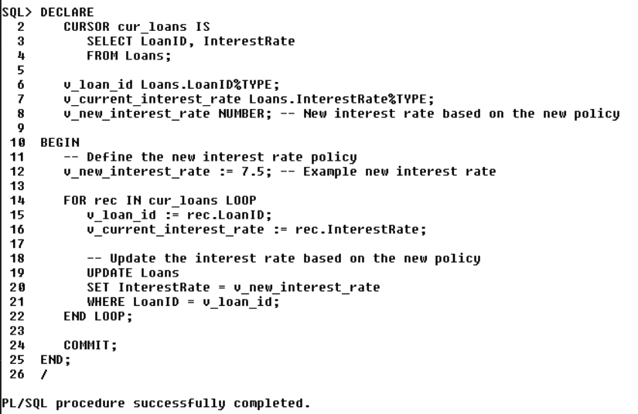

**Output:**

